SHHS ALUMNI ASSOCIATION
2012 SCHOLARSHIP RECIPIENTS


Kaitlyn Nicole Spangler

Kaitlyn will graduate with a 3.83 GPA and plans to continue her studies at Towson University in the Nursing program and eventually pursue a Doctorate. She is a member of the National Honor Society at South High and is captain of the cheerleading squad and softball team. In addition, Kaitlyn is a member of the Link Crew, color guard, Band, Student Government Association, and also serves as an office aide. Kaitlyn currently volunteers in the Emergency Room at Meritus Medical Center.

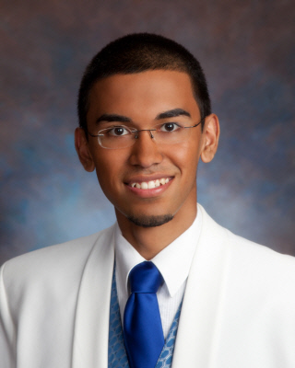
Umar Mahmood

While maintaining a 4.0 GPA at South High, Umar was a member of the Mosque Youth Group, Key Club, Media Club, Green Crew, and was voted Most Spirited/Most Likely to Succeed. Umar plans to continue his studies in biomedical/radiology and has been accepted to several universities; his decision on which to attend is still pending. He currently volunteers with Red Cross blood drives and has completed some intern work with a radiologist in Hagerstown. In addition, Umar represented the student body by helping with the strategic planning of the Washington County Free Library.


Sarah Dawn Bjerga

Sarah aspires to be an art educator and will continue her studies at Hagerstown Community College and Liberty University. She has completed honors classes during her years at South High and maintains a 4.1 GPA. Sarah is a tutor for AVID students, is a volunteer with Children’s Ministries, Coffee Café, and numerous church activities. Her art work is very much appreciated at her church, in the community, and at South High.

SHHS ALUMNI ASSOCIATION
2012 SCHOLARSHIP RECIPIENTS

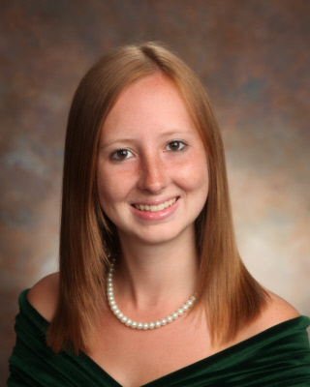
Stephanie Swope

Stephanie maintains a 4.27 GPA while performing her duties as President of the Student Government Association, Vice President of Key Club and Rebel Band. She also works with the Youth United Way and Antietam Exchange Club. As Stephanie continues her education, she will major in biology and statistics and minor in chemistry, with the ultimate goal of becoming a neonatologist. Stephanie has been accepted to Towson University.


Teri Jene Keller

Teri is a member of the National Honor Society and will be continuing her education at Salisbury University with a career goal of becoming a veterinarian. Teri maintains a 3.92 GPA while being a member of the Key Club, color guard, Link Crew, and Green Crew. By volunteering at Hagerstown Community College in the College for Kids Program, she has developed a sense of balance and excellent work ethic.


Lauren Fahrney

Lauren plans to continue her education at Hagerstown Community College and then transfer to a four year institution in order to obtain a Bachelors of Science in Nursing. She maintained a 3.69 GPA while playing basketball and volleyball for South High. She is a member of the National Honor Society, Link Crew, and Key Club. In addition, Lauren is a Red Cross volunteer, works part-time at Direct Mail Processors, and sends cards to U.S. troops currently serving our country.

