IN 2012 IT WILL BE 40 YEARS SINCE WE WERE ALL TOGETHER…

THE GREAT CLASS OF 1972

WHAT: A REBEL VACATION CRUISE ON THE CARNIVAL FUN SHIP ‘PRIDE’
WHEN: 7 NIGHTS, SUNDAY TO SUNDAY, APRIL 15TH – APRIL 22ND 2012
WHERE: LEAVING FROM THE PORT OF BALTIMORE

COST: PRICES START AT $589 TO $1159 PER PERSON DEPENDING ON THE TYPE OF CABIN YOU CHOOSE
AS YOU KNOW, ALL FOOD (24 HRS A DAY) AND ENTERTAINMENT IS INCLUDED IN THE PRICE OF A CRUISE. COFFEE/TEA/LEMONAID INCLUDED - ALCOHOL AND SODA ARE EXTRA.
A $250 DEPOSIT PER PERSON IS REQUIRED AT THE TIME OF BOOKING WITH THE BALANCE DUE BEFORE 02/01/2012.

THIS FANTASTIC RATE IS AN EARLY BOOKING SPECIAL. THE LONGER YOU WAIT TO BOOK, THE HIGHER THE RATE WILL BE. IT IS RECOMMENDED YOU BOOK WITHIN ONE MONTH FROM TODAY FOR THE BEST RATE. IF A LOWER PROMOTIONAL RATE BECOMES AVAILABLE, IT WILL BE PASSED ON TO US.

OUR CONTACT/CRUISE SPECIALIST IS Carl Duran 1-800-764-7315 X82360 cduran2@carnival.com He works 8AM-4:30PM EST and is off on Tues and Sat.
CALL CARL AND BOOK TODAY – TELL HIM YOU ARE BOOKING FOR THE SOUTH HIGH 1972 CRUISE!!!

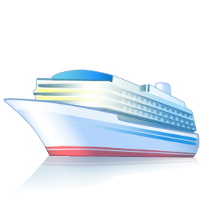
ITINERARY:

DAY PORT ARRIVE DEPART
SUN APR 15 BALTIMORE, MD 4:30PM
MON APR 16 FUN DAY @ SEA
TUE APR 17 FUN DAY @ SEA
WED APR 18 PORT CANAVERAL (ORLANDO) FLORIDA 7:00AM 7:00PM
THU APR 19 NASSAU, BAHAMAS 11:00AM 10:00PM
FRI APR 20 FREEPORT, BAHAMAS 7:00AM 2:00PM
SAT APR 21 FUN DAY @ SEA
SUN APR 22 BALTIMORE, MD 9:00AM

GO TO WWW.CARNIVAL.COM TO SEE THE SHIP, CHOOSE YOUR CABIN AND START DREAMING!

